**SPRAWOZDANIE**

Zajęcia: Grafika komputerowa

Prowadzący: mgr Mikołaj Grygiel

**Laboratorium 8**

26.05.2024

**Temat:** Tekstury w OpenGL

**Wariant**: 1

Radosław Skrzypczyński

Informatyka I stopień,

niestacjonarne,

4 semestr,

Gr. 1B

1. **Polecenie:**

**2. Wprowadzane dane:**

Menu z przyciskami do ustawiania parametrów sceny i obiektu

**3. Wykorzystane komendy:**

texture-from-color-buffer.html

*<!DOCTYPE html>*

*<html>*

*<!--*

*Draws a 2D scene using OpenGL, then copies that scene to a*

*texture image so that it can be applied as a texture to a*

*3D object. The scene can be animated.*

*-->*

*<head>*

*<meta charset="UTF-8" />*

*<title>Texture From Color Buffer</title>*

*<link rel="stylesheet" href="../demo.css" />*

*<script src="./script/demo-core.js"></script>*

*<script src="./script/glsim.js"></script>*

*<script src="./script/teapot-model-IFS.js"></script>*

*<script src="./script/basic-object-models-IFS.js"></script>*

*<script>*

*var camera;*

*var canvas; // the canvas on which we will draw.*

*var frameNumber = 0; // frame number for the animation*

*var sphere, cubeModel, cylinder, cone, torus, teapot, piramida; // model data for six objects.*

*/* The display function, which draws the content of the canvas.*

*\*/*

*function draw() {*

*var objectNumber = Number(document.getElementById("object").value); // which object to draw.*

*/* First, draw the 2D scene, using a 256-by256 viewport to get a power-of-two texture. */*

*glDisable(GL_LIGHTING);*

*glDisable(GL_DEPTH_TEST);*

*glDisable(GL_TEXTURE_2D);*

*glViewport(0, 0, 256, 256); // Note that canvas must be at least 256-by-256.*

*glMatrixMode(GL_PROJECTION);*

*glLoadIdentity();*

*glOrtho(0, 7, -1, 5, -1, 1); // Limits requied by 2D scene*

*glMatrixMode(GL_MODELVIEW);*

*draw2DScene();*

*if (objectNumber == 7) {*

*return; // Just show the 2D scene as the image in the canvas.*

*}*

*/* Copy the image into the texture. */*

*glCopyTexImage2D(GL_TEXTURE_2D, 0, GL_RGBA, 0, 0, 256, 256, 0);*

*/* Since we do not have mipmaps for the texture, we MUST set the texture*

*minimication filter to GL_NEAREST or GL_LINEAR, since the default*

*filter requires mipmaps. */*

*glTexParameteri(GL_TEXTURE_2D, GL_TEXTURE_MIN_FILTER, GL_LINEAR);*

*/* Now, draw the shape, with the texture */*

*glEnable(GL_LIGHTING);*

*glEnable(GL_DEPTH_TEST);*

*glEnable(GL_TEXTURE_2D);*

*glViewport(0, 0, canvas.width, canvas.height); // restore full viewport!*

*camera.apply(); // (Sets up projection and viewing transforms.)*

*glClearColor(0, 0, 0, 1);*

*glClear(GL_COLOR_BUFFER_BIT | GL_DEPTH_BUFFER_BIT);*

*switch (objectNumber) {*

*case 0:*

*glRotatef(-90, 1, 0, 0);*

*glScalef(1.5, 1.5, 1.5);*

*drawModel(sphere);*

*break;*

*case 1:*

*glScalef(1.2, 1.2, 1.2);*

*drawModel(cubeModel);*

*break;*

*case 2:*

*glRotatef(-90, 1, 0, 0);*

*glScalef(1.3, 1.3, 1.3);*

*drawModel(cylinder);*

*break;*

*case 3:*

*glRotatef(-90, 1, 0, 0);*

*glScalef(1.3, 1.3, 1.3);*

*drawModel(cone);*

*break;*

*case 4:*

*glScalef(1.6, 1.6, 1.6);*

*drawModel(torus);*

*break;*

*case 5:*

*glScalef(0.06, 0.06, 0.06);*

*drawModel(teapot);*

*break;*

*case 6:*

*glScalef(0.7, 0.7, 0.7);*

*drawModel(piramida);*

*break;*

*}*

*}*

*/\*\**

*\* Draws a model using glDrawElements. The model data must be in the format produced by*

*\* the functions in basic-object-models-IFS.js.*

*\*/*

*function drawModel(model) {*

*glEnableClientState(GL_VERTEX_ARRAY);*

*glVertexPointer(3, GL_FLOAT, 0, model.vertexPositions);*

*glEnableClientState(GL_NORMAL_ARRAY);*

*glNormalPointer(GL_FLOAT, 0, model.vertexNormals);*

*glEnableClientState(GL_TEXTURE_COORD_ARRAY);*

*glTexCoordPointer(2, GL_FLOAT, 0, model.vertexTextureCoords);*

*glDrawElements(*

*GL_TRIANGLES,*

*model.indices.length,*

*GL_UNSIGNED_BYTE,*

*model.indices*

*);*

*glDisableClientState(GL_VERTEX_ARRAY);*

*glDisableClientState(GL_NORMAL_ARRAY);*

*glDisableClientState(GL_TEXTURE_COORD_ARRAY);*

*}*

*function initGL() {*

*glEnable(GL_LIGHT0);*

*glEnable(GL_NORMALIZE);*

*glMaterialfv(GL_FRONT_AND_BACK, GL_AMBIENT_AND_DIFFUSE, [1, 1, 1, 1]); // white material for texturing.*

*}*

*//----------------- Drawing the 2D scene ----------------------------------------*

*/\**

*\* Draw a 32-sided regular polygon as an approximation for a circular disk.*

*\* (This is necessary since OpenGL has no commands for drawing ovals, circles,*

*\* or curves.) The disk is centered at (0,0) with a radius given by the*

*\* parameter.*

*\*/*

*function drawDisk(radius) {*

*var d;*

*glBegin(GL_POLYGON);*

*for (d = 0; d < 32; d++) {*

*var angle = ((2 * Math.PI) / 32) * d;*

*glVertex2d(radius * Math.cos(angle), radius * Math.sin(angle));*

*}*

*glEnd();*

*}*

*/\**

*\* Draw a wheel, centered at (0,0) and with radius 1. The wheel has 15 spokes*

*\* that rotate in a clockwise direction as the animation proceeds.*

*\*/*

*function drawWheel() {*

*var i;*

*glColor3f(0, 0, 0);*

*drawDisk(1);*

*glColor3f(0.75, 0.75, 0.75);*

*drawDisk(0.8);*

*glColor3f(0, 0, 0);*

*drawDisk(0.2);*

*glRotatef(frameNumber * 20, 0, 0, 1);*

*glBegin(GL_LINES);*

*for (i = 0; i < 15; i++) {*

*glVertex2f(0, 0);*

*glVertex2d(*

*Math.cos((i * 2 * Math.PI) / 15),*

*Math.sin((i * 2 * Math.PI) / 15)*

*);*

*}*

*glEnd();*

*}*

*/\**

*\* Draw a cart consisting of a rectangular body and two wheels. The wheels*

*\* are drawn by the drawWheel() method; a different translation is applied to each*

*\* wheel to move them into position under the body. The body of the cart*

*\* is a red rectangle with corner at (0,-2.5), width 5, and height 2. The*

*\* center of the bottom of the rectangle is at (0,0).*

*\*/*

*function drawCart() {*

*glPushMatrix();*

*glTranslatef(-1.5, -0.1, 0);*

*glScalef(0.8, 0.8, 1);*

*drawWheel();*

*glPopMatrix();*

*glPushMatrix();*

*glTranslatef(1.5, -0.1, 0);*

*glScalef(0.8, 0.8, 1);*

*drawWheel();*

*glPopMatrix();*

*glColor3f(1, 0, 0);*

*glBegin(GL_POLYGON);*

*glVertex2f(-2.5, 0);*

*glVertex2f(2.5, 0);*

*glVertex2f(2.5, 2);*

*glVertex2f(-2.5, 2);*

*glEnd();*

*}*

*/\**

*\* Draw a sun with radius 0.5 centered at (0,0). There are also 13 rays which*

*\* extend outside from the sun for another 0.25 units.*

*\*/*

*function drawSun() {*

*var i;*

*glColor3f(1, 1, 0);*

*for (i = 0; i < 13; i++) {*

*// Draw 13 rays, with different rotations.*

*glRotatef(360 / 13, 0, 0, 1); // Note that the rotations accumulate!*

*glBegin(GL_LINES);*

*glVertex2f(0, 0);*

*glVertex2f(0.75, 0);*

*glEnd();*

*}*

*drawDisk(0.5);*

*glColor3f(0, 0, 0);*

*}*

*/\**

*\* Draw a windmill, consisting of a pole and three vanes. The pole extends from the*

*\* point (0,0) to (0,3). The vanes radiate out from (0,3). A rotation that depends*

*\* on the frame number is applied to the whole set of vanes, which causes the windmill*

*\* to rotate as the animation proceeds. Note that this method changes the current*

*\* transform in the GL context gl! The caller of this subroutine should take care*

*\* to save and restore the original transform, if necessary.*

*\*/*

*function drawWindmill() {*

*var i;*

*glColor3f(0.8, 0.8, 0.9);*

*glBegin(GL_POLYGON);*

*glVertex2f(-0.05, 0);*

*glVertex2f(0.05, 0);*

*glVertex2f(0.05, 3);*

*glVertex2f(-0.05, 3);*

*glEnd();*

*glTranslatef(0, 3, 0);*

*glRotated(frameNumber * (180.0 / 46), 0, 0, 1);*

*glColor3f(0.4, 0.4, 0.8);*

*for (i = 0; i < 3; i++) {*

*glRotated(120, 0, 0, 1); // Note: These rotations accumulate.*

*glBegin(GL_POLYGON);*

*glVertex2f(0, 0);*

*glVertex2f(0.5, 0.1);*

*glVertex2f(1.5, 0);*

*glVertex2f(0.5, -0.1);*

*glEnd();*

*}*

*}*

*/* Draws the entire 2D scene.*

*\*/*

*function draw2DScene() {*

*glClearColor(0.7, 0.8, 1.0, 1.0);*

*glClear(GL_COLOR_BUFFER_BIT); // Fills the scene with blue.*

*glLoadIdentity();*

*/* Draw three green triangles to form a ridge of hills in the background */*

*glColor3f(0, 0.6, 0.2);*

*glBegin(GL_POLYGON);*

*glVertex2f(-3, -1);*

*glVertex2f(1.5, 1.65);*

*glVertex2f(5, -1);*

*glEnd();*

*glBegin(GL_POLYGON);*

*glVertex2f(-3, -1);*

*glVertex2f(3, 2.1);*

*glVertex2f(7, -1);*

*glEnd();*

*glBegin(GL_POLYGON);*

*glVertex2f(0, -1);*

*glVertex2f(6, 1.2);*

*glVertex2f(20, -1);*

*glEnd();*

*/* Draw a bluish-gray rectangle to represent the road. */*

*glColor3f(0.4, 0.4, 0.5);*

*glBegin(GL_POLYGON);*

*glVertex2f(0, -0.4);*

*glVertex2f(7, -0.4);*

*glVertex2f(7, 0.4);*

*glVertex2f(0, 0.4);*

*glEnd();*

*/* Draw a white line to represent the stripe down the middle*

*\* of the road. */*

*glLineWidth(4); // Set the line width to be 6 pixels.*

*glColor3f(1, 1, 1);*

*glBegin(GL_LINES);*

*glVertex2f(0, 0);*

*glVertex2f(7, 0);*

*glEnd();*

*glLineWidth(1); // Reset the line width to be 1 pixel.*

*/* Draw the sun. The drawSun method draws the sun centered at (0,0). A 2D translation*

*\* is applied to move the center of the sun to (5,3.3). A rotation makes it rotate*/*

*glPushMatrix();*

*glTranslated(5.8, 3, 0);*

*glRotated(-frameNumber * 0.7, 0, 0, 1);*

*drawSun();*

*glPopMatrix();*

*/* Draw three windmills. The drawWindmill method draws the windmill with its base*

*\* at (0,0), and the top of the pole at (0,3). Each windmill is first scaled to change*

*\* its size and then translated to move its base to a different paint. In the animation,*

*\* the vanes of the windmill rotate. That rotation is done with a transform inside the*

*\* drawWindmill method. */*

*glPushMatrix();*

*glTranslated(0.75, 1, 0);*

*glScaled(0.6, 0.6, 1);*

*drawWindmill();*

*glPopMatrix();*

*glPushMatrix();*

*glTranslated(2.2, 1.6, 0);*

*glScaled(0.4, 0.4, 1);*

*drawWindmill();*

*glPopMatrix();*

*glPushMatrix();*

*glTranslated(3.7, 0.8, 0);*

*glScaled(0.7, 0.7, 1);*

*drawWindmill();*

*glPopMatrix();*

*/* Draw the cart. The drawCart method draws the cart with the center of its base at*

*\* (0,0). The body of the cart is 5 units long and 2 units high. A scale is first*

*\* applied to the cart to make its size more reasonable for the picture. Then a*

*\* translation is applied to move the cart horizontally. The amount of the translation*

*\* depends on the frame number, which makes the cart move from left to right across*

*\* the screen as the animation progresses. The cart animation repeats every 300*

*\* frames. At the beginning of the animation, the cart is off the left edge of the*

*\* screen. */*

*glPushMatrix();*

*glTranslated(-3 + (13 * (frameNumber % 300)) / 300.0, 0, 0);*

*glScaled(0.3, 0.3, 1);*

*drawCart();*

*glPopMatrix();*

*} // end display*

*//-------------------------------------------------------------------------------*

*var animating = false;*

*function frame() {*

*if (animating) {*

*frameNumber++;*

*draw();*

*setTimeout(frame, 30);*

*}*

*}*

*function doAnimate() {*

*animating = document.getElementById("animate").checked;*

*if (animating) {*

*frame();*

*}*

*}*

*function init() {*

*try {*

*canvas = document.getElementById("maincanvas");*

*glsimUse(canvas, null); // ( The "null" gives an RGBA color buffer instead of RGB.*

*// It is needed here because the call to copyTexImage2D*

*// uses the RGBA format. )*

*} catch (e) {*

*document.getElementById("canvas-holder").innerHTML =*

*"<p><b>Sorry, an error occurred:<br>" + e + "</b></p>";*

*return;*

*}*

*initGL();*

*document.getElementById("object").value = "1";*

*document.getElementById("object").onchange = draw;*

*document.getElementById("animate").checked = false;*

*document.getElementById("animate").onchange = doAnimate;*

*camera = new Camera();*

*camera.setScale(1);*

*camera.lookAt(2, 2, 5, 0, 0, 0, 0, 1, 0);*

*camera.installTrackball(draw);*

*sphere = uvSphere();*

*cubeModel = cube();*

*cylinder = uvCylinder();*

*cone = uvCone();*

*torus = uvTorus();*

*piramida = uvCone(1, 1, 7);*

*teapot = teapotModel; // (This one is just a variable, defined in teapot-model-IFS.js)*

*draw();*

*}*

*</script>*

*</head>*

*<body onload="init()">*

*<div id="content">*

*<h3 id="headline">Drawing a Texture</h3>*

*<div id="canvas-holder">*

*<canvas id="maincanvas" width="400" height="350"></canvas>*

*</div>*

*<br clear="all" />*

*<p style="text-indent: 30px">*

*<b>Object</b>:*

*<select id="object">*

*<option value="0">Sphere</option>*

*<option value="1">Cube</option>*

*<option value="2">Cylinder</option>*

*<option value="3">Cone</option>*

*<option value="4">Torus</option>*

*<option value="5">Teapot</option>*

*<option value="6">Piramida</option>*

*<option value="7">SHOW 2D SCENE</option>*

*</select>*

*<label*

*><input type="checkbox" id="animate" style="margin-left: 30px" /><b*

*>Animate</b*

*></label*

*>*

*</p>*

*</div>*

*<div id="help-content" style="display: none">*

*<h3>About this demo...</h3>*

*<p>*

*This program demonstrates the use of the OpenGL function*

*<i>glCopyTexImage2D</i>, which copies an image from the color buffer*

*(where OpenGL draws its images) into a texture. This makes it possible*

*to draw an image with OpenGL and then use the image as a texture on*

*other objects.*

*</p>*

*<p>*

*A pop-up menu lets you select the object on which the texture image is*

*used. The last entry in the menu is "SHOW 2D SCENE." In that case, you*

*see the color buffer just after the 2D scene has been drawn, instead of*

*seeing a 3D object with the scene as a texture. Note that the 2D scene*

*does not fill the canvas. In fact, it is drawn in a 256-by-256 viewport,*

*since the width and height of a texture image should be powers of two.*

*</p>*

*<p>*

*If you turn on animation, the scene shown in the texture image is*

*animated. A new version of the scene is drawn and copied to the texture*

*for each frame. In this case, the texture image is a 2D*

*cart-and-windmill animation that should be familiar from other examples.*

*</p>*

*<p>As usual, you can rotate the 3D objects using your mouse.</p>*

*</div>*

*<!-- support for help text -- do not change. -->*

*<div id="help-icon">*

*<img*

*src="../image/question32.png"*

*onclick="showDemoHelp()"*

*title="Click here for information about this demo."*

*width="32"*

*height="32"*

*/>*

*</div>*

*<div id="hide-help-icon">*

*<img*

*src="../image/close32.png"*

*onclick="showDemoHelp()"*

*title="Click here to return to the demo."*

*width="65"*

*height="32"*

*/>*

*</div>*

*<div id="helpBG" style="display: none"></div>*

*</body>*

*</html>*

texture-transform.html

*<!DOCTYPE html>*

*<html>*

*<!--*

*Shows a variety of texture images on a variety of objects, with*

*a variety of texture transforms, all under the user's control.*

*-->*

*<head>*

*<meta charset="UTF-8">*

*<title>Textures and Texture Transforms</title>*

*<link rel="stylesheet" href="../demo.css">*

*<style>*

*#texcanvas {*

*background-image: url("textures/NightEarth-512x256.jpg");*

*background-size: 100px 100px;*

*}*

*</style>*

*<script src="./script/demo-core.js"></script>*

*<script src="./script/glsim.js"></script>*

*<script src="./script/teapot-model-IFS.js"></script>*

*<script src="./script/basic-object-models-IFS.js"></script>*

*<script src="./script/slider-canvas.js"></script>*

*<script>*

*var camera;*

*var graphics; // for drawing on the canvas that shows the texture*

*var frameNumber = 0; // frame number for the animation*

*var sphere, cubeModel, cylinder, cone, torus, teapot, piramida; // model data for six objects.*

*var sliderScale, sliderTranslateX, sliderTranslateY, sliderRotate;*

*var scale = 1;*

*var translateX = 0;*

*var translateY = 0;*

*var rotate = 0;*

*var loadingImages = true;*

*var textureImages = new Array(); // Will hold Image objects loaded from image URLs.*

*var textureImageURLs = [*

*"textures/brick001.jpg",*

*"textures/Earth-1024x512.jpg",*

*"textures/NightEarth-512x256.jpg",*

*"textures/marble.jpg",*

*"textures/metal003.gif",*

*"textures/mandelbrot.jpeg",*

*"textures/zad/brick.jpg",*

*"textures/zad/clouds.jpg",*

*"textures/zad/earth.jpg"*

*];*

*function draw() {*

*scale = sliderScale.value(0);*

*rotate = sliderRotate.value(0);*

*translateX = sliderTranslateX.value(0);*

*translateY = sliderTranslateY.value(0);*

*drawTextureCanvas(); // Draws the canvas that displays the texture.*

*glClear(GL_COLOR_BUFFER_BIT | GL_DEPTH_BUFFER_BIT);*

*if (loadingImages) {*

*return;*

*}*

*var texnum = Number(document.getElementById("texture").value);*

*var objectNumber = Number(document.getElementById("object").value);*

*var image = textureImages[texnum];*

*glEnable(GL_TEXTURE_2D);*

*glTexImage2D(GL_TEXTURE_2D,0,GL_RGBA,image.width,image.height,0,GL_RGBA,GL_UNSIGNED_BYTE,image);*

*glTexParameteri(GL_TEXTURE_2D, GL_TEXTURE_MIN_FILTER, GL_LINEAR); // MUST set this since we don't have mipmaps*

*glMatrixMode(GL_TEXTURE);*

*glLoadIdentity();*

*glTranslatef(translateX,translateY, 0);*

*glRotatef(rotate,0,0,1);*

*glScalef(scale,scale,1);*

*glMatrixMode(GL_MODELVIEW);*

*camera.apply();*

*switch(objectNumber) {*

*case 0:*

*glRotatef(-90,1,0,0);*

*glScalef(1.5,1.5,1.5);*

*drawModel(sphere);*

*break;*

*case 1:*

*glScalef(1.2,1.2,1.2);*

*drawModel(cubeModel);*

*break;*

*case 2:*

*glRotatef(-90,1,0,0);*

*glScalef(1.3,1.3,1.3);*

*drawModel(cylinder);*

*break;*

*case 3:*

*glRotatef(-90,1,0,0);*

*glScalef(1.3,1.3,1.3);*

*drawModel(cone);*

*break;*

*case 4:*

*glScalef(1.6,1.6,1.6);*

*drawModel(torus);*

*break;*

*case 5:*

*glScalef(0.06, 0.06, 0.06);*

*drawModel(teapot);*

*break;*

*case 6:*

*glRotatef(-90,1,0,0);*

*glScalef(0.6,0.6,0.6);*

*drawModel(piramida);*

*break;*

*}*

*}*

*function drawTextureCanvas() {*

*if (loadingImages) {*

*graphics.fillStyle = "white";*

*graphics.fillRect(0,0,300,300);*

*graphics.fillStyle = "black";*

*graphics.font = "14px serif";*

*graphics.fillText("Waiting for images to load...", 10, 40);*

*return;*

*}*

*graphics.clearRect(0,0,300,300);*

*graphics.save();*

*graphics.translate(100,200);*

*graphics.scale(1,-1);*

*graphics.translate(translateX*100,translateY*100);*

*graphics.rotate(rotate/180 * Math.PI);*

*graphics.scale(scale,scale);*

*graphics.lineWidth = 5/scale;*

*graphics.strokeStyle = "white";*

*graphics.strokeRect(-.5,-.5,100,100);*

*graphics.lineWidth = 1/scale;*

*graphics.strokeStyle = "black";*

*graphics.strokeRect(-.5,-.5,100,100);*

*graphics.restore();*

*}*

*/\*\**

*\* Draws a model using glDrawElements. The model data must be in the format produced by*

*\* the functions in basic-object-models-IFS.js.*

*\*/*

*function drawModel(model) {*

*glEnableClientState(GL_VERTEX_ARRAY);*

*glVertexPointer(3,GL_FLOAT,0,model.vertexPositions);*

*glEnableClientState(GL_NORMAL_ARRAY);*

*glNormalPointer(GL_FLOAT, 0, model.vertexNormals);*

*glEnableClientState(GL_TEXTURE_COORD_ARRAY);*

*glTexCoordPointer(2,GL_FLOAT,0,model.vertexTextureCoords);*

*glDrawElements(GL_TRIANGLES, model.indices.length, GL_UNSIGNED_BYTE, model.indices);*

*glDisableClientState(GL_VERTEX_ARRAY);*

*glDisableClientState(GL_NORMAL_ARRAY);*

*glDisableClientState(GL_TEXTURE_COORD_ARRAY);*

*}*

*function initGL() {*

*glEnable(GL_LIGHTING);*

*glEnable(GL_LIGHT0);*

*glEnable(GL_NORMALIZE);*

*glEnable(GL_DEPTH_TEST);*

*glMaterialfv(GL_FRONT_AND_BACK, GL_AMBIENT_AND_DIFFUSE, [ 1, 1, 1, 1 ]); // white, for texturing*

*glClearColor(0,0,0,1);*

*}*

*function loadImages() {*

*var loadedCt = 0;*

*for (var i = 0; i < textureImageURLs.length; i++) {*

*textureImages[i] = new Image();*

*textureImages[i].onload = imageLoaded;*

*textureImages[i].src = textureImageURLs[i];*

*}*

*function imageLoaded() {*

*loadedCt++;*

*if (loadedCt == textureImageURLs.length) {*

*loadingImages = false;*

*glEnable(GL_TEXTURE_2D);*

*var texnum = Number(document.getElementById("texture").value);*

*var image = textureImages[texnum];*

*try {*

*glTexImage2D(GL_TEXTURE_2D,0,GL_RGBA,image.width,image.height,0,GL_RGBA,GL_UNSIGNED_BYTE,image);*

*} catch(e) {*

*// Some browsers (Chrome at least) get a Security error if they try to use an image from the local disk.*

*document.getElementById("headline").innerHTML="Can't access texture.<br>Note: Some browsers can't use a file from a local disk."*

*return;*

*}*

*glTexParameteri(GL_TEXTURE_2D, GL_TEXTURE_MIN_FILTER, GL_LINEAR); // MUST set this since we don't have mipmaps*

*draw();*

*document.getElementById("object").disabled = false;*

*document.getElementById("texture").disabled = false;*

*}*

*}*

*}*

*function changeTexture() {*

*var texnum = Number(document.getElementById("texture").value);*

*document.getElementById("texcanvas").style.backgroundImage = "url('" + textureImageURLs[texnum] + "')";*

*var image = textureImages[texnum];*

*glTexImage2D(GL_TEXTURE_2D,0,GL_RGBA,image.width,image.height,0,GL_RGBA,GL_UNSIGNED_BYTE,image);*

*draw();*

*}*

*function doReset() {*

*sliderRotate.setValue(0,0);*

*sliderScale.setValue(0,1);*

*sliderTranslateX.setValue(0,0);*

*sliderTranslateY.setValue(0,0);*

*camera.lookAt(10,7,20);*

*draw();*

*}*

*function init() {*

*try {*

*glsimUse("maincanvas");*

*var texcanvas = document.getElementById("texcanvas");*

*graphics = texcanvas.getContext('2d');*

*}*

*catch (e) {*

*document.getElementById("canvas-holder").innerHTML="<p><b>Sorry, an error occurred:<br>" +*

*e + "</b></p>";*

*return;*

*}*

*document.getElementById("reset").onclick = doReset;*

*document.getElementById("object").value = "1";*

*document.getElementById("object").onchange = draw;*

*document.getElementById("texture").value = "2";*

*document.getElementById("texture").onchange = changeTexture;*

*document.getElementById("object").disabled = true;*

*document.getElementById("texture").disabled = true;*

*sliderRotate = new SliderCanvas(document.getElementById("scRotate"));*

*sliderRotate.addSlider({label:"rotate", min:-180, max:180, value:0});*

*sliderScale = new SliderCanvas(document.getElementById("scScale"));*

*sliderScale.addSlider({label:"scale", min: 0.5, max:2, step:0.01, value:1, decimals:2});*

*sliderTranslateX = new SliderCanvas(document.getElementById("scTransX"));*

*sliderTranslateX.addSlider({label:"x-trans.", min: -0.5, max:0.5, step:0.01, value:0, decimals:2});*

*sliderTranslateY = new SliderCanvas(document.getElementById("scTransY"));*

*sliderTranslateY.addSlider({label:"y-trans.", min: -0.5, max:0.5, step:0.01, value:0, decimals:2});*

*sliderRotate.onChange = draw;*

*sliderScale.onChange = draw;*

*sliderTranslateX.onChange = draw;*

*sliderTranslateY.onChange = draw;*

*initGL();*

*camera = new Camera();*

*camera.setScale(1);*

*camera.lookAt(10,7,20);*

*camera.installTrackball(draw);*

*sphere = uvSphere();*

*cubeModel = cube();*

*cylinder = uvCylinder();*

*cone = uvCone();*

*torus = uvTorus();*

*teapot = teapotModel;*

*piramida = uvCone(1,2,12);*

*sliderRotate.draw();*

*sliderScale.draw();*

*sliderTranslateX.draw();*

*sliderTranslateY.draw();*

*drawTextureCanvas();*

*loadImages();*

*}*

*</script>*

*</head>*

*<body onload="init()">*

*<div id="content">*

*<h3 id="headline">Textures and Texture Transforms</h3>*

*<table border="0" cellspacing="0" cellpadding="8">*

*<tr>*

*<td><div id="canvas-holder"><canvas id="texcanvas" width="300" height="300"></canvas></div></td>*

*<td><canvas id="maincanvas" width="300" height="300"></canvas></td>*

*</tr>*

*<tr align="center">*

*<td colspan="2">*

*<b>Texture:</b>*

*<select id="texture">*

*<option value="0">Brick</option>*

*<option value="1">Topographic Earth</option>*

*<option value="2">Earth At Night</option>*

*<option value="3">Marble</option>*

*<option value="4">Metal</option>*

*<option value="5">Mandelbrot</option>*

*<option value="6">zad - brick</option>*

*<option value="7">zad - clouds</option>*

*<option value="8">zad - earth</option>*

*</select>*

*<b style="margin-left:40px">Object</b>:*

*<select id="object">*

*<option value="0">Sphere</option>*

*<option value="1">Cube</option>*

*<option value="2">Cylinder</option>*

*<option value="3">Cone</option>*

*<option value="4">Torus</option>*

*<option value="5">Teapot</option>*

*<option value="6">Piramida</option>*

*</select>*

*<button id="reset" style="margin-left:40px">Reset</button>*

*</td>*

*</tr>*

*<tr align=center>*

*<td>*

*<canvas id="scScale" width="280" height="50"></canvas>*

*</td>*

*<td>*

*<canvas id="scTransX" width="280" height="50"></canvas>*

*</td>*

*</tr>*

*<tr align=center>*

*<td>*

*<canvas id="scRotate" width="280" height="50"></canvas>*

*</td>*

*<td>*

*<canvas id="scTransY" width="280" height="50"></canvas>*

*</td>*

*</tr>*

*</table>*

*</div>*

*<div id="help-content" style="display:none">*

*<h3>About this demo...</h3>*

*<p>Textured objects are shown in the display at the upper right.*

*Use the pop-up menus to select the texture and the object that*

*you want to view. You can use your mouse to rotate the objects.</p>*

*<p>The display on the upper left shows the <i>st</i>-plane, where*

*the texture lives. In the display, <i>s</i> and <i>t</i> range*

*from &minus;1 to 2. A box is drawn around the original texture*

*image, with <i>s</i> and <i>t</i> ranging from 0 to 1. The*

*point (0,0) is at the lower left corner of that box. Note that*

*(0,0) is not at the center of the display.</p>*

*<p>Four sliders allow you apply texture transformations. The*

*transform can be seen as a coordinate transformation in the <i>st</i>-plane, or*

*as a modeling transformation that applies to the box. As a modeling transform,*

*the box is first scaled, then rotated, then translated. </p>*

*<p>The same transform is also applied as a texture transformation on the textured*

*object. The result*

*is easiest to see on the cube: <i>Each face of the cube shows a copy*

*of the part of the <i>st</i>-plane that is inside the box.</i> </p>*

*<p>Try adjusting just*

*one slider while the others are at their default values.*

*(Click "Reset" between experiments.) Note that when the*

*box is translated to the left, the image on the cube moves to the right.*

*When the box grows, the image on the cube shrinks (because you are*

*seeing a larger region in the <i>st</i>-plane mapped to the same*

*area on the cube). When the box rotates counterclockwise, the*

*image on the cube rotates clockwise.</p>*

*<p>Although the effect is easiest to understand on the cube, it's*

*fun to watch a texture moving around on an object. Try it!*

*I especially like a rotating texture on the torus.</p>*

*</div>*

*<!-- support for help text -- do not change. -->*

*<div id="help-icon">*

*<img src="../image/question32.png" onclick="showDemoHelp()"*

*title="Click here for information about this demo." width="32" height="32">*

*</div>*

*<div id="hide-help-icon">*

*<img src="../image/close32.png" onclick="showDemoHelp()"*

*title="Click here to return to the demo." width="65" height="32">*

*</div>*

*<div id="helpBG" style="display:none"></div>*

*</body>*

*</html>*

Link do zdalnego repozytorium: https://github.com/Slayzerus/UBB_GrafikaKomputerowa/tree/main/Lab%208

**4. Wynik działania:**

texture-from-color-buffer.html

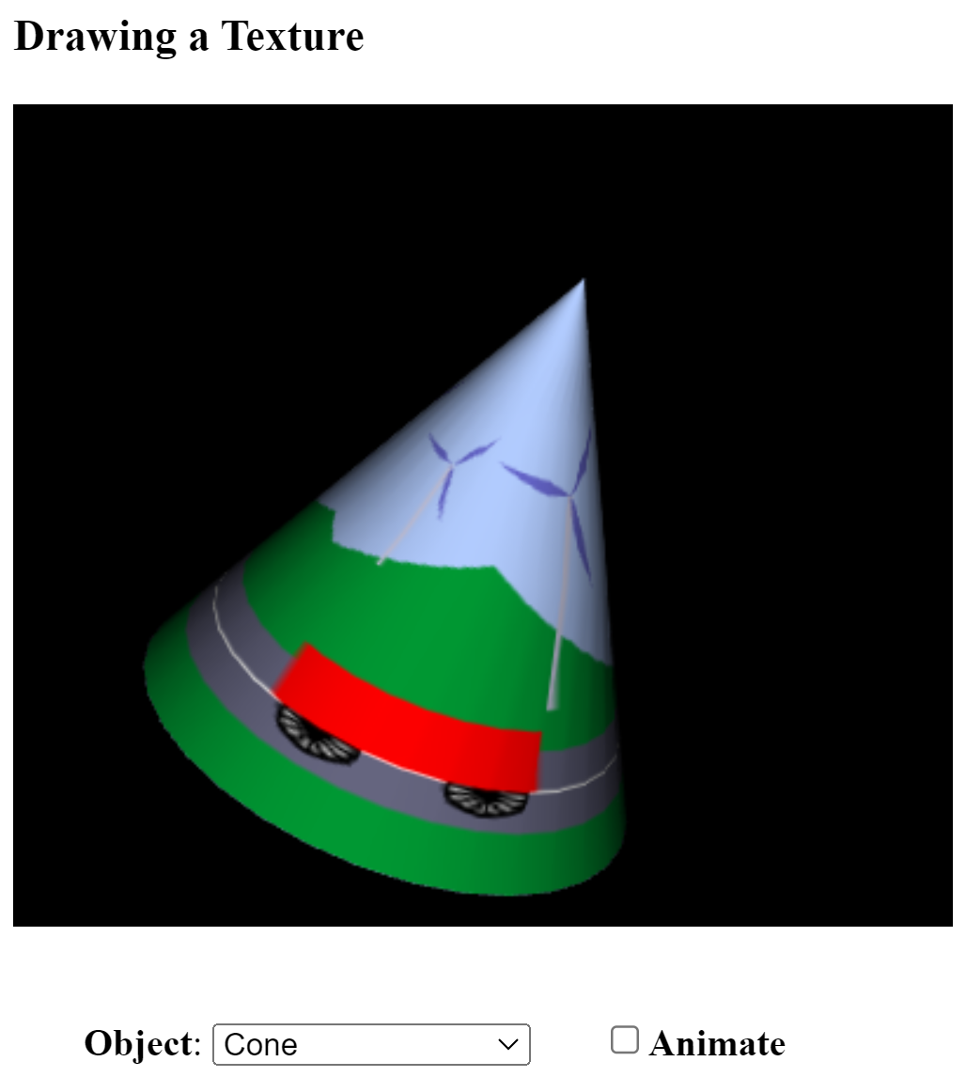

texture-transform.html

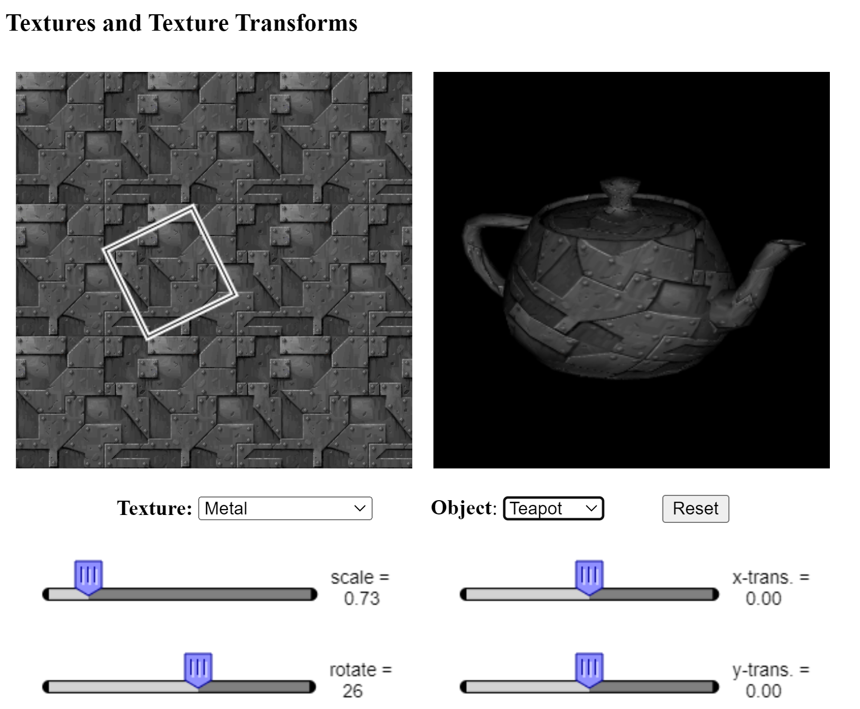

**5. Wnioski:**

Podczas realizacji zadania dotyczącego tekstur w OpenGL dokonano kluczowych obserwacji i wyciągnięto istotne wnioski. Tekstury w grafice 3D są niezwykle ważne, ponieważ pozwalają na dodanie szczegółów, które trudno osiągnąć jedynie poprzez modelowanie geometryczne. W OpenGL, szczególnie w starszych wersjach, obrazy tekstur muszą mieć wymiary będące potęgami liczby 2, co zapewnia kompatybilność i optymalną wydajność. Współrzędne tekstur, przypisywane każdemu wierzchołkowi obiektu, definiują, które fragmenty tekstury będą na niego mapowane. Interpolacja tych wartości wewnątrz prymitywu umożliwia dokładne odwzorowanie tekstury na jego powierzchni.

Filtrowanie tekstur i mipmapowanie znacząco poprawiają jakość obrazu, zwłaszcza podczas skalowania. Transformacje tekstur, takie jak skalowanie, obrót i translacja, pozwalają dostosować sposób mapowania tekstury na powierzchnię obiektu, analogicznie do transformacji obiektów w przestrzeni 3D. Tekstury można ładować zarówno z pamięci komputera, jak i z bufora kolorów. Wprowadzenie obiektów tekstury w OpenGL 1.1 umożliwia bardziej efektywne zarządzanie wieloma teksturami, co pozwala na szybkie przełączanie między nimi bez konieczności wielokrotnego ładowania danych.

W trakcie zadania teksturowano piramidę za pomocą dwóch metod: ładowania tekstury z pliku oraz tworzenia tekstury z bufora kolorów. Te praktyczne działania pokazały, jak ważne jest zrozumienie zarówno teorii, jak i specyficznych funkcji dostępnych w OpenGL. Prawidłowe zarządzanie współrzędnymi tekstur i ich przekształceniami jest kluczowe dla osiągnięcia pożądanych efektów wizualnych. Filtrowanie i mipmapy są niezbędne do poprawy jakości tekstur, szczególnie przy dynamicznej zmianie ich rozmiarów podczas renderowania. Efektywne zarządzanie teksturami za pomocą obiektów tekstury znacząco poprawia wydajność aplikacji grafiki 3D.

Podsumowując, zadanie dostarczyło cennego doświadczenia w pracy z teksturami w OpenGL, podkreślając ich znaczenie w tworzeniu realistycznych i estetycznych scen 3D. Zastosowanie różnych technik teksturowania, w tym ładowania z pliku i bufora kolorów, pozwoliło na lepsze zrozumienie i opanowanie tych metod. Praktyczne zastosowanie teorii tekstur w połączeniu z funkcjami OpenGL umożliwiło stworzenie bardziej realistycznych i atrakcyjnych wizualnie obiektów. Wnioski te są istotne dla każdego, kto pragnie tworzyć zaawansowaną grafikę komputerową.